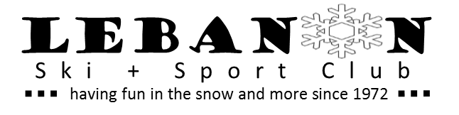
Lebanon Ski & Sports Club, Inc.
Membership / Release of Liability Form

MEMBERSHIP YEAR 2017 / 2018

Membership begins April 1 and expires Mar 31st

Bring to Membership Meeting or Mail to:
Deb Binkley, 2566 State Rte 72 Jonestown PA 17038

All trip participants must be current LSSCI members

Membership Type: New Member Renewal

Family - $20.00 Individual - $15.00

Name First: ___________________________________ Last: _____________________________________________

Address ______________________________________________________________

City: _________________ State: ___________ ZIP: ________

Phone: ____________________Cell __________________

Email address: ___________________________________________________

List names of family members and ages here, if applying for Family Membership:

Payment record: Check #__________ membership date: _____
Release of Liability
The Lebanon Ski & Sports Club Inc. (LSSCI) reserves the right to make changes including, but not limited to price, time, departure point, lodging, air flights, etc., where such changes are in the best interest of LSSCI or are compelled by circumstances beyond LSSCI’s control. Neither LSSCI nor its board members, trip leaders or other representatives assume any obligation or responsibility for any matters not within their control.
I acknowledge that skiing & boarding and other physical activities are hazardous activities and I have made a voluntary choice to participate in those activities despite the risks that they present. In consideration of my being permitted to participate in Club events, I agree to assume any and all risks of injury or death which might be associated with or result from my participating in this event.
I understand that this is a Release of Liability, which will legally prevent me or any other person from filing suit or making any other legal claim for damages against the Lebanon Ski & Sport Club, Inc. in the event of my death or any injury to me. I, nevertheless, enter into this agreement freely and voluntary and agree that it is binding upon me, my heirs, assignees and legal representatives.
I agree as an individual or on behalf of family, to abide by the provisions and conditions in the trip Agreement and Terms or any other trip material, including information appearing in the Lebanon Ski & Sport Club, Inc. newsletter which information shall be part of the agreement.
I agree as an individual or on behalf of family or those under 18 years of age, to abide by the provisions and conditions in the trip Agreement and Terms
I agree to make schedule payments when due. If I make late payments, make changes or withdraw from the trip, I agree to pay shift, late or cancellation fees as specified in the trip material.

I, the undersigned, have read, understand and will abide by all statements, rules and regulations in the Application.

Print Name___________________________________________________ Date______________________

Signature(s) ______________________________ ___________________________________

